Assignment No: 6.1

1. How do you evaluate the performance of a project in agile?

Ans: Some of the important key measures to evaluate performance of a project in agile are:
- Sprint report cards:
These are report cards which explains about sprint performance of the projects. Key measures include:
  - Velocity: How many story points can the team complete in a sprint
  - Hit Rate: This shows the actual percentage of work completed out of the work assigned to a timebox
  - Work remaining on tasks: It is done on a daily basis where the team estimates the works to be completed on each active task. Burndown charts are also used here.
  - Project Costs: It includes
      - Cost performance Index (CPI) = (Baseline cost per story point)/(Actual cost per story point)
      - Schedule performance Index (SPI) = (Actual velocity)/(Baseline Velocity)
      - Earned Business value (EBV) = It measures the outcomes of the project and not the outputs.
- Project Report Cards:
These are report cards given to the customer where he need to fill it up based on his experience with the product owner and the Dev team. Some of the questions in the report card include: Timeliness of project, Team’s ability to react to changes, Quality of products delivered, Level of collaboration experineced with Product owner and the Dev team etc. The customer need to rate these statements based on his experience with the team.
- Product owner report card: This is a report card in which the Product owner will rate the Dev team based on his experience during the course of the project completion.
- Project Peer Review reports: These are reports on which the team members will rate among one another.
- Annual Agile performance review: It is done mostly by the project directors and agile managers where they take into account all those above reports and and average it. Here the directors will evaluate the performance of the team as a whole.

2. Compare traditional monitoring & control with agile monitoring & control with respect to metrics generation?

Ans:
Traditional Monitoring and Control | Agile Monitoring and control
1. Concerned about measuring actual performance against plan  2. Project managers track factors such as cost quality and effort  3. Designed for a hierarchical environment  4. Little feedback  5. Limited appraisal over a time period  6. Goals are set once and at the beginning  7. Project managers will calculate CPI and SPI | 1. It is designed for collaborative environment  2. Regular feedback  3. Regular check-ins over the progress of the project.  4. Goals set can be changed if business priorities shift over the progress of the project.  5. In agile CPI and SPI are calculated and also the Earned Business Value is also calculated here. It counts the outcomes and not the outputs.

3. With a total project budget of $ 175,000, and having completed one out of
four Iterations, we have this product backlog and these actuals:

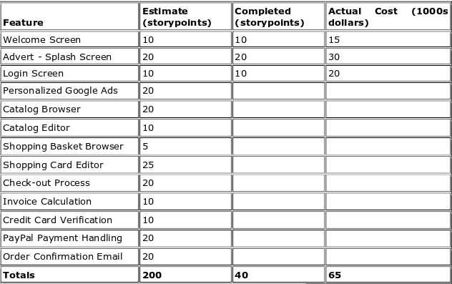
(in our example, after Iteration 1 we should be at 25% complete)

Calculate:
- Planned value
- Actual Percentage complete
- Earned value

Ans: Planned value = Total project budget * planned completion rate
= $ 175,000 * 25%
= $ 43,750

Actual Percentage complete = Completed story points/Total story points
= 40/200
= 20%

Earned value = Total project budget * Actual completion rate
= $ 175,000 * 20%
= $ 35,000

